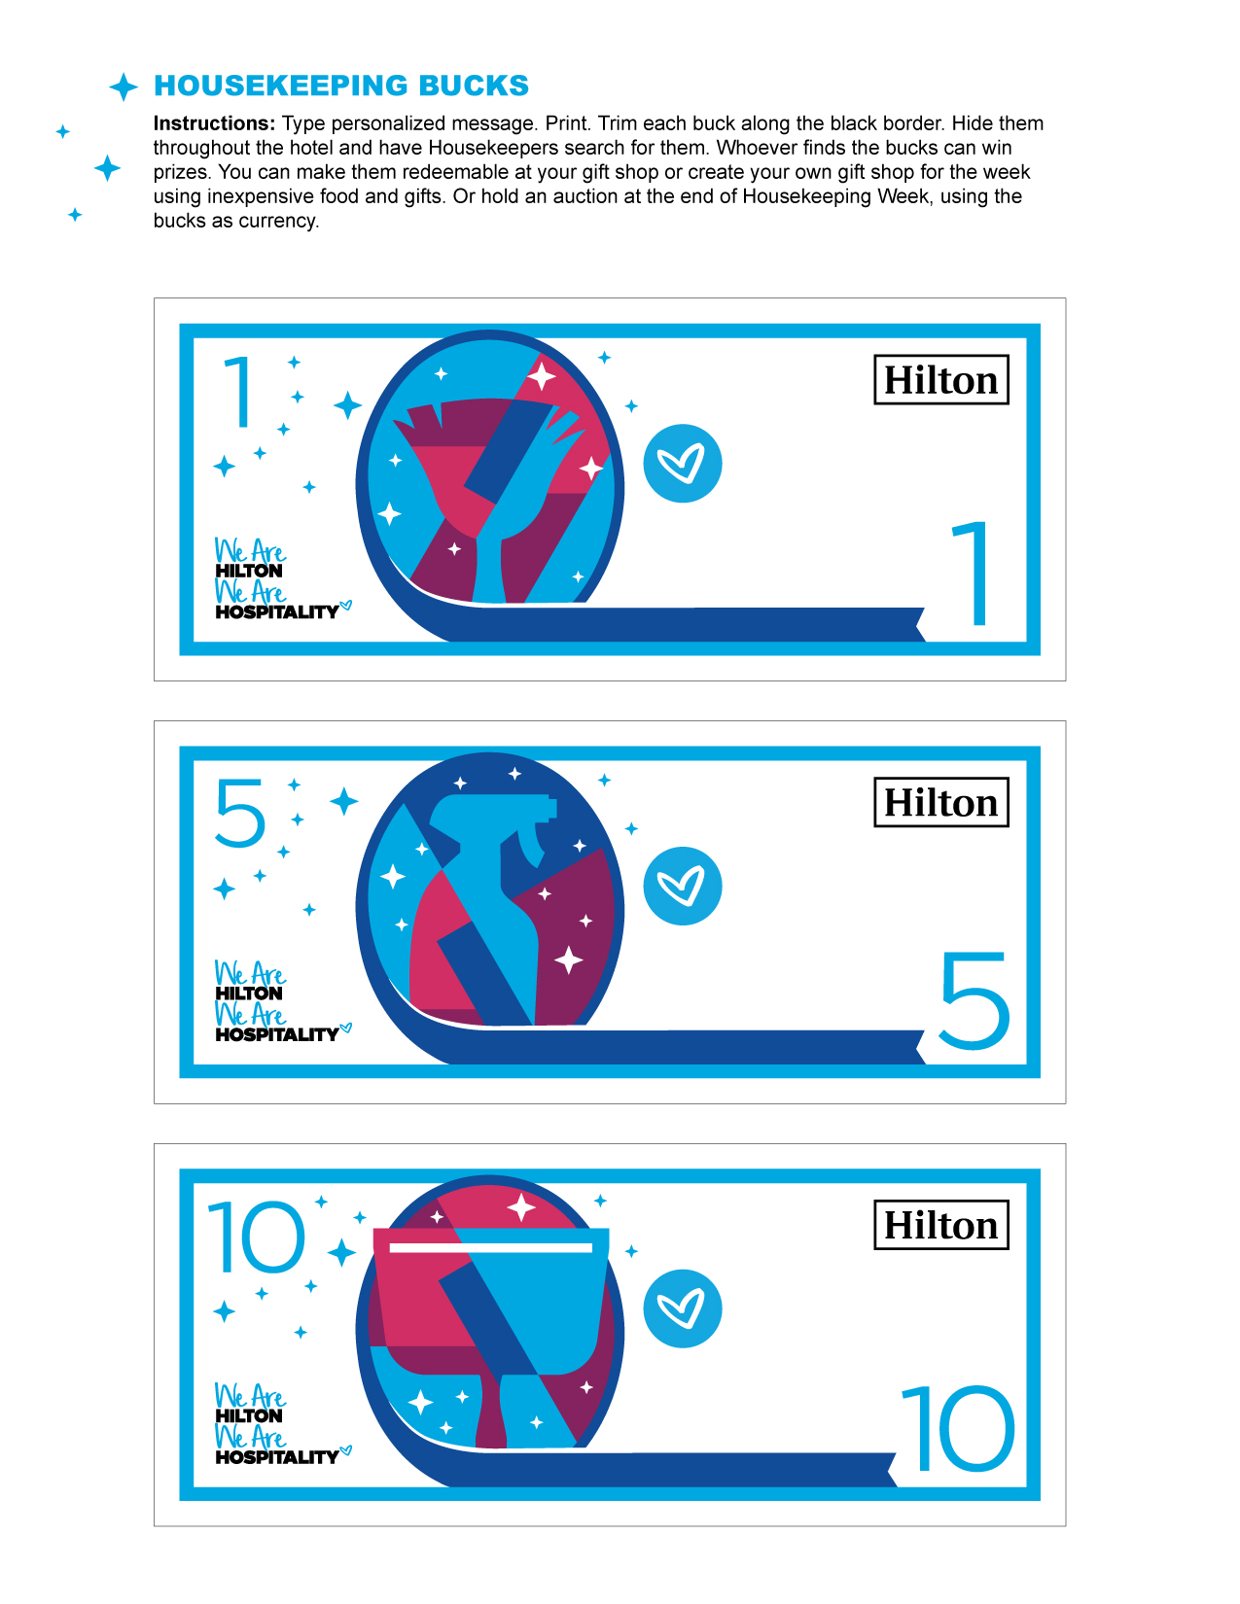

Type message here. You have up to two lines for your message.

Type message here. You have up to two lines for your message.

September 8–14, 2019

FIVE HOUSEKEEPING BUCKS

Type message here. You have up to two lines for your message.

September 8–14, 2019

September 8–14, 2019

ONE HOUSEKEEPING BUCK

International

Housekeeping

Week 2019

International

Housekeeping

Week 2019

TEN HOUSEKEEPING BUCKS

International

Housekeeping

Week 2019