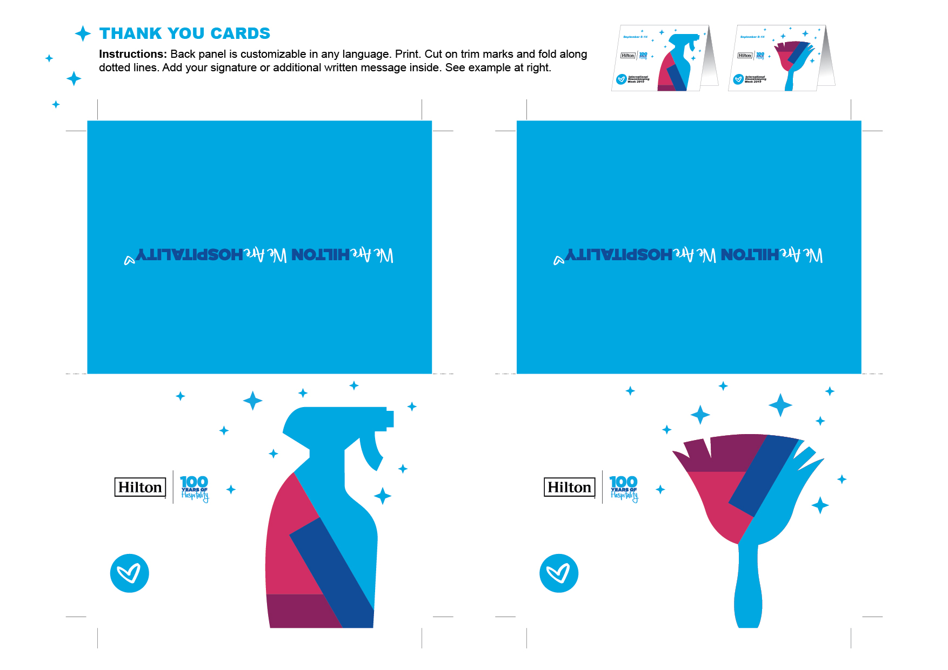

**September 8-14**

**September 8-14**

**International**

**Housekeeping**

**Week 2019**

**International**

**Housekeeping**

**Week 2019**