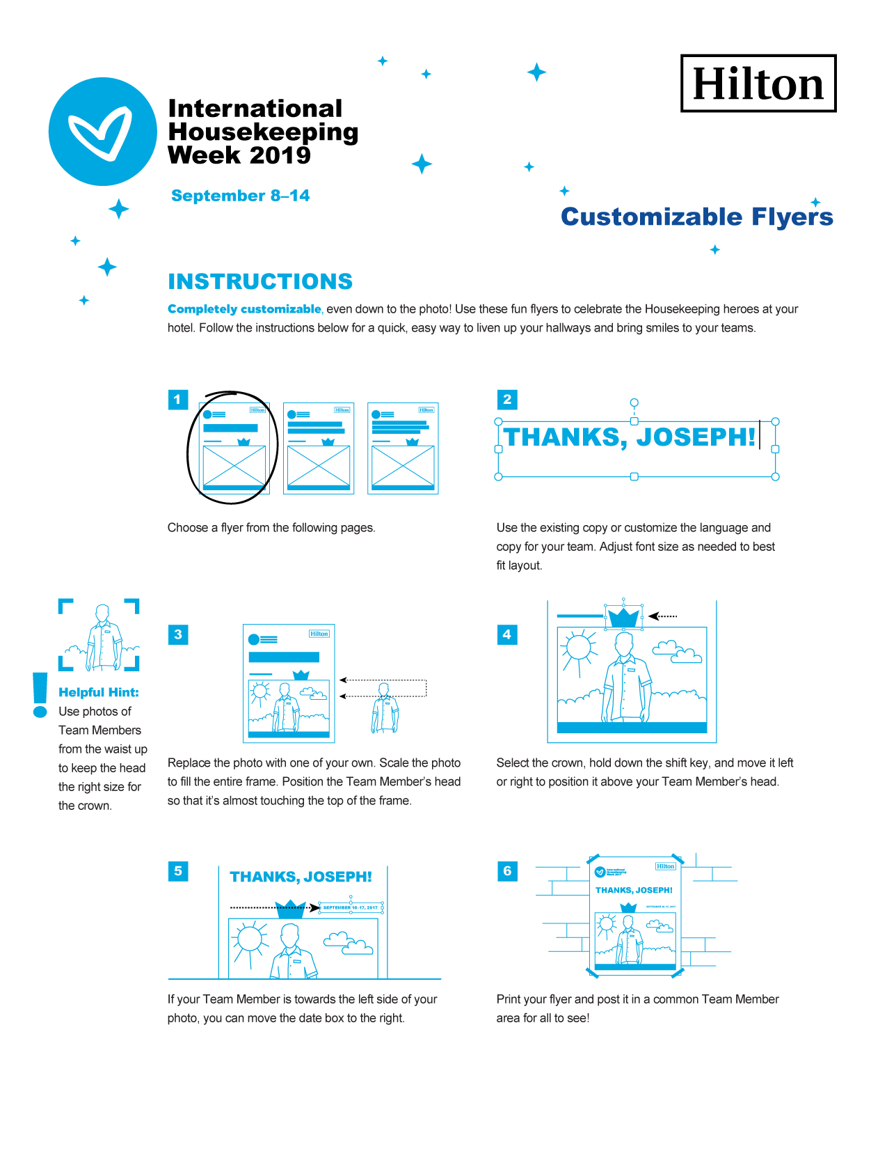

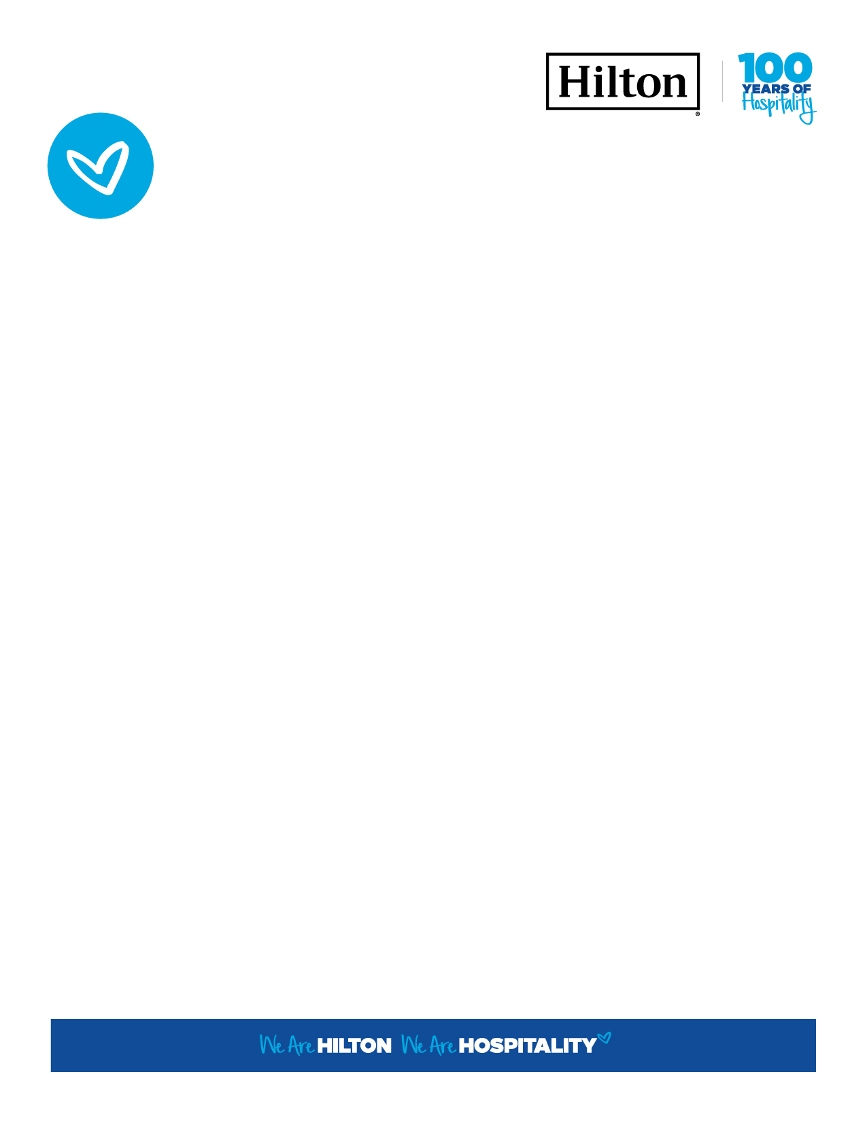

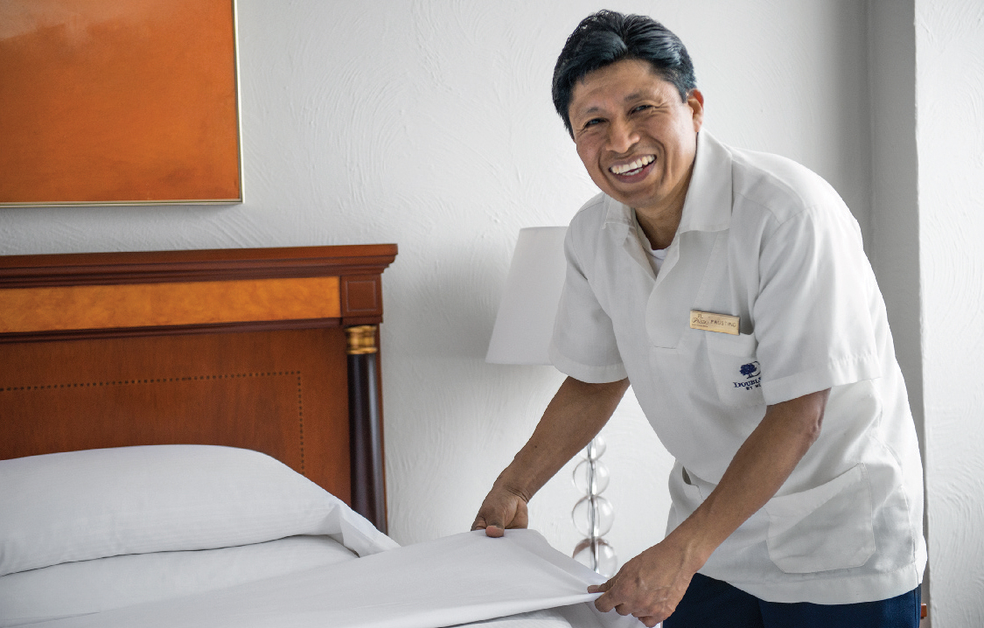

YOU RULE!

International

Housekeeping

Week 2019

September 8–14

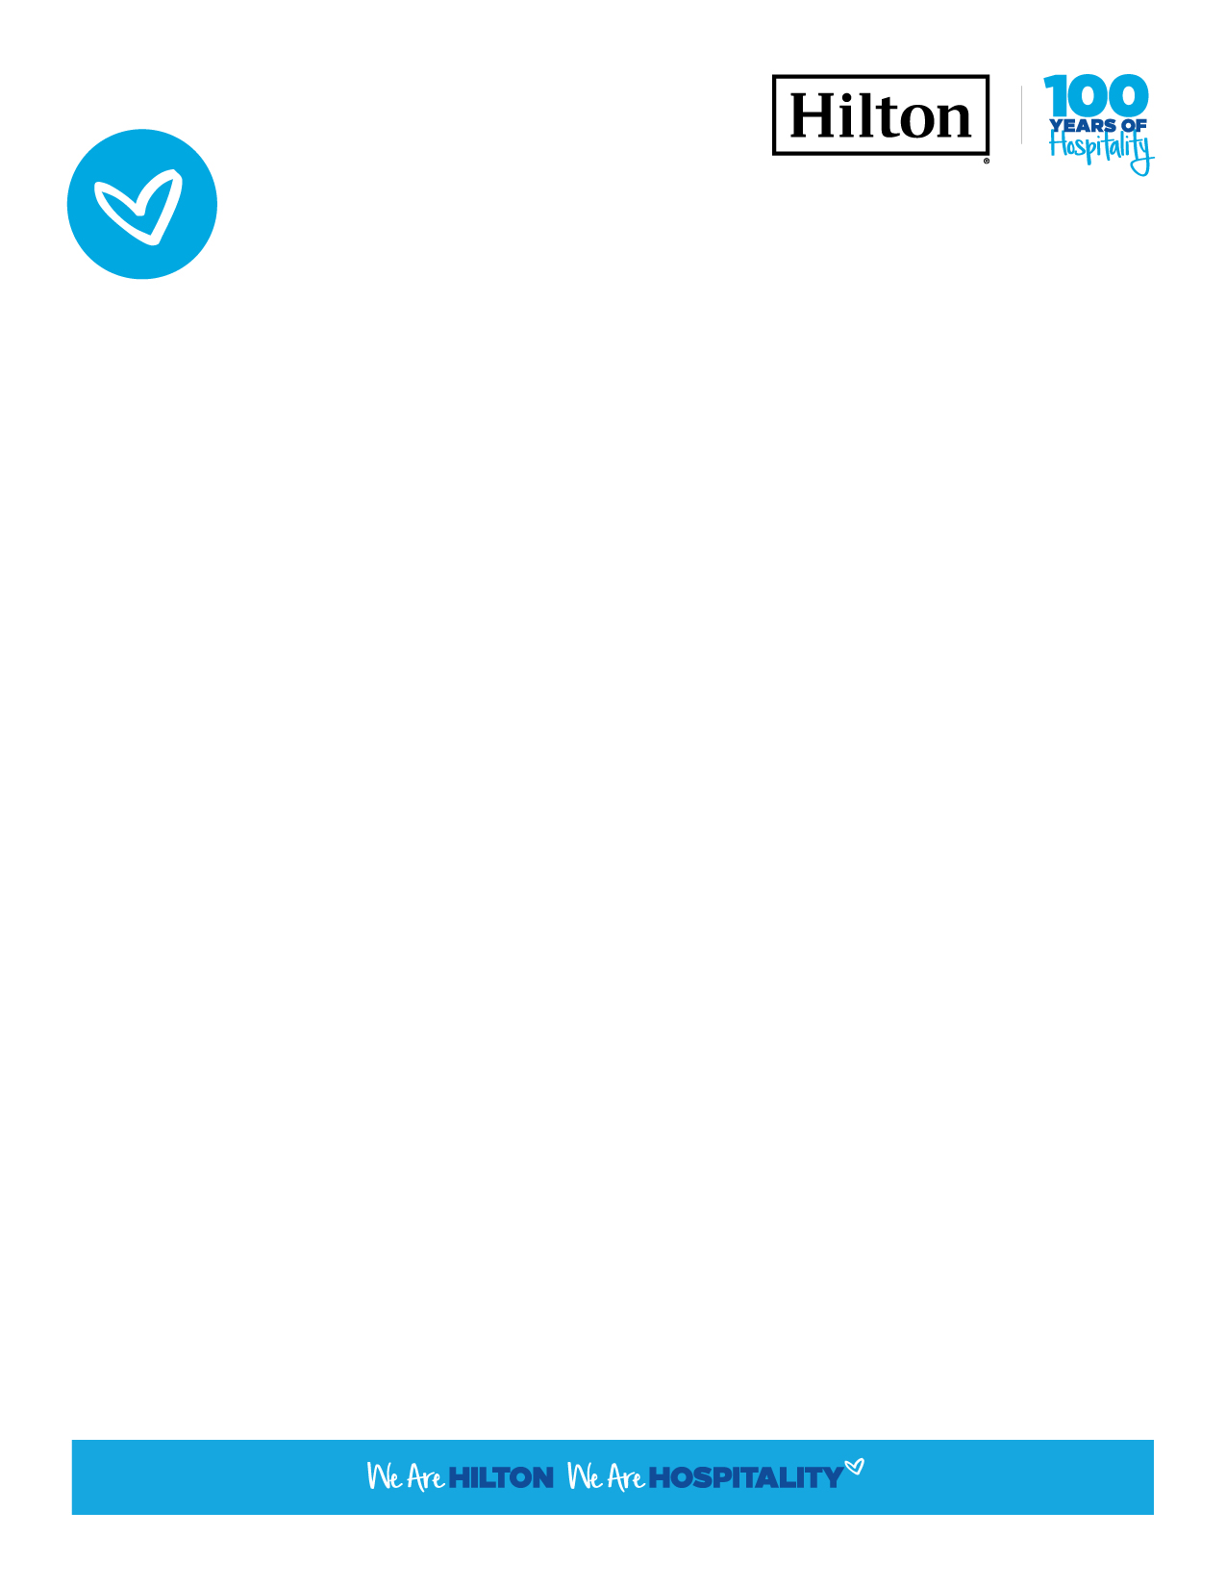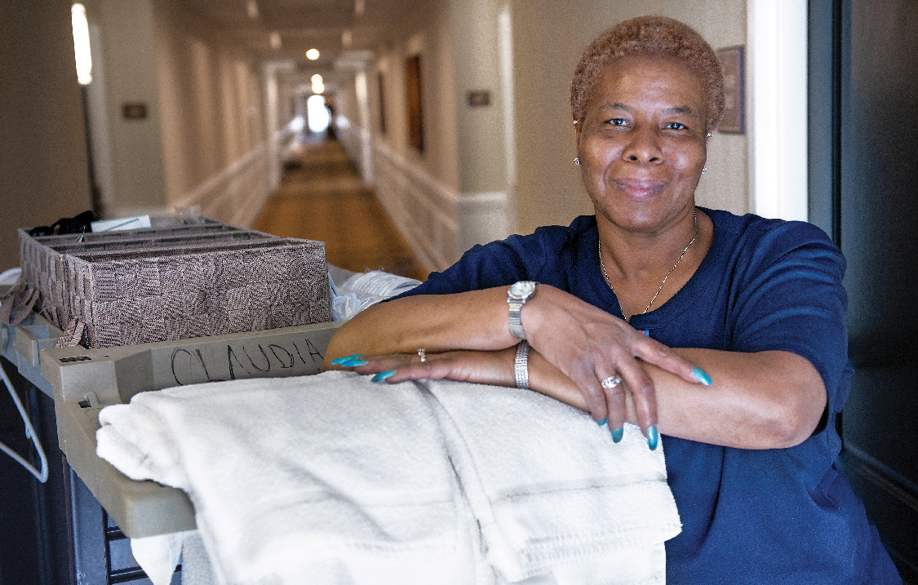

International

Housekeeping

Week 2019

HAIL, CLAUDIA, QUEEN OF CLEAN

September 8–14

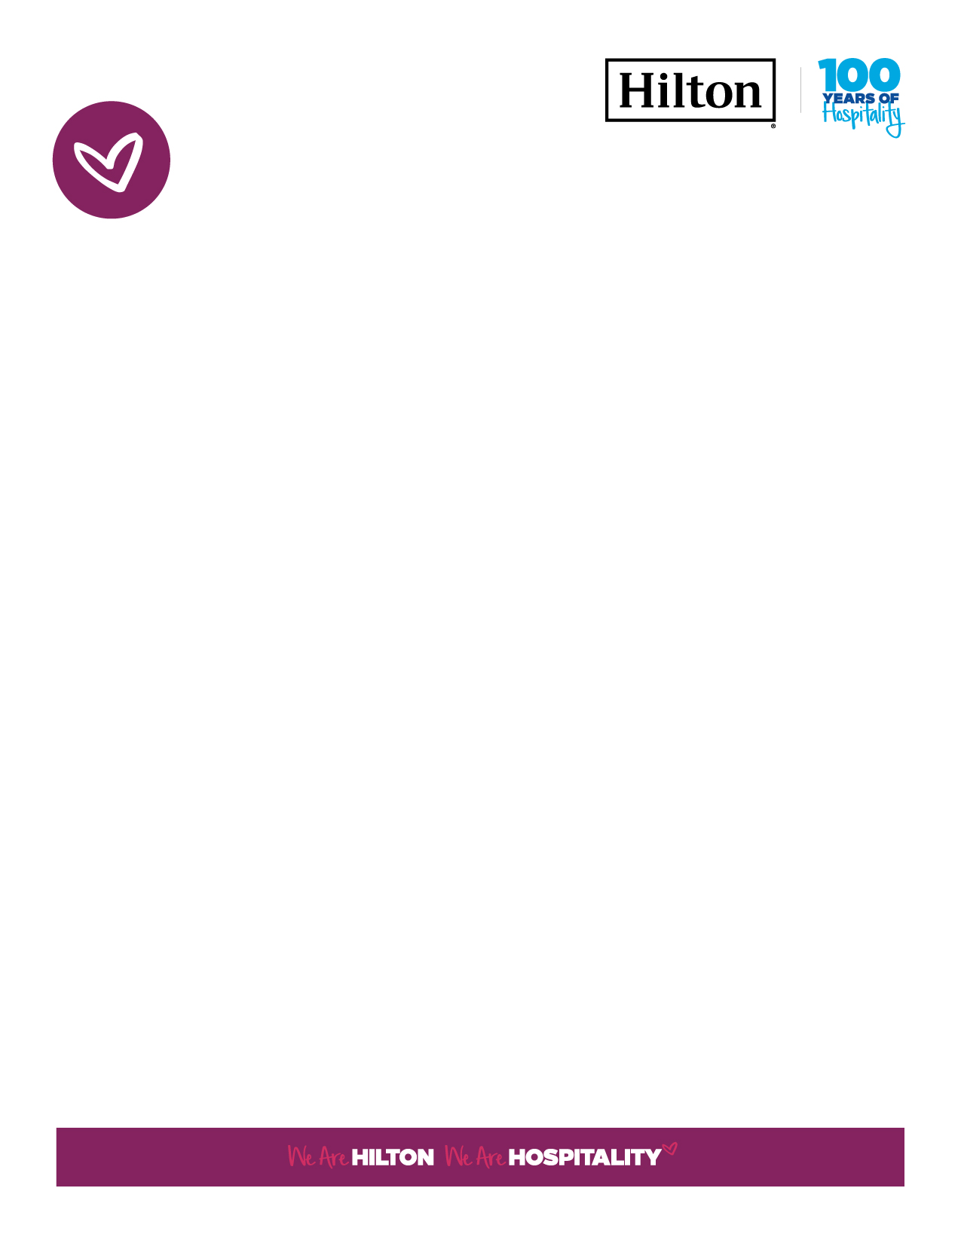

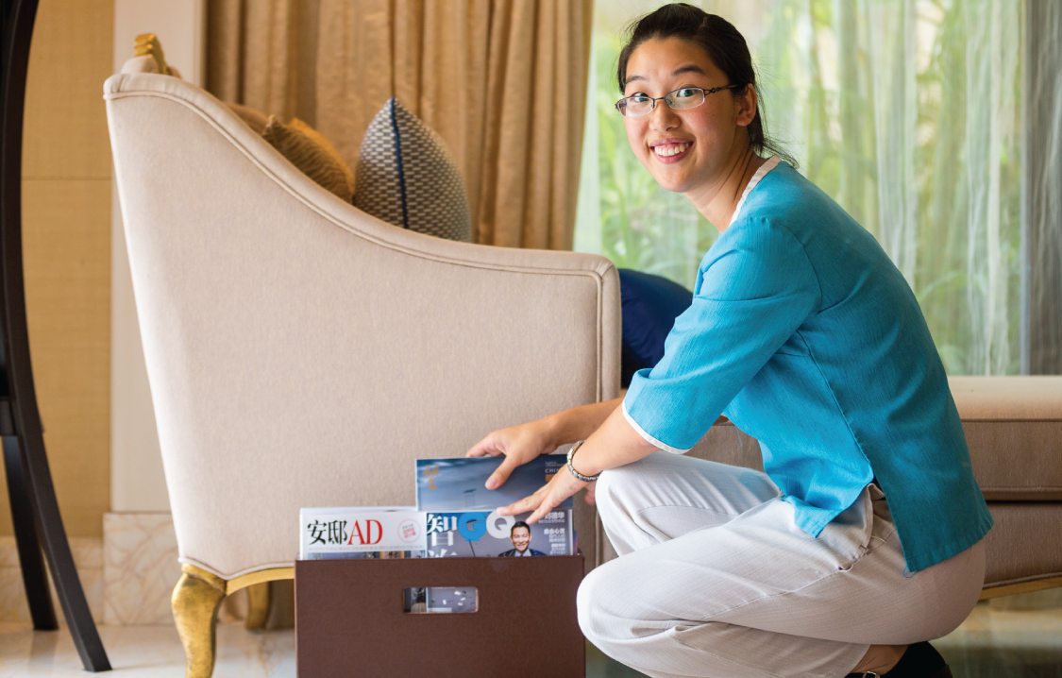

September 8–14

THANK YOU TO OUR

KINGS AND QUEENS OF HOSPITALITY!

International

Housekeeping

Week 2019