Local press coverage for your International Housekeeping Week efforts can reap rich rewards at your hotel. It can positively impact Guests and Team Members alike, as well
as your bottom line. It’s not difficult to write and distribute a press release on your
own. Here are some simple steps, as well as a press release template to get you started.

Tips on Writing a Press Release:

- Follow the template provided on page three.
- Decide why you are writing a press release and determine your focus.
- Keep it short and to the point. Usually, press releases are no more than one page.
- In your intro paragraph, include information about why this event is newsworthy and how it relates to the local community.
- Include some tantalizing peripheral details or facts to spark curiosity in the following paragraphs. A good press release not only informs but also teases.
- Brevity is not only allowed, but encouraged and rewarded.
- A quote by a company representative (i.e. GM or HR Manager) adds credibility to your release.

-----------------------------------------------------------------------------------------------------------------
Tips on Sending a Press Release:

- Identify news outlets that will be most interested in what you have to say (local newspapers, television stations, industry-related publications, et. al.).
- Identify editors & reporters from your list. You may find a webpage with a Contact Us section specific to each news outlet.
- Only send your release to one person per news outlet.
- Email is generally preferred among journalists, but you may fax it. If you do email it, please be sure to copy the release content into the body of the email and not attach it (attachments will most likely not be read for fear of viruses).
- After sending your press release, wait a day or so and email or call the news outlet to make sure they received it. Since most newspapers get a lot of press releases, it’s hard for editors to read them all. Following up can ensure that someone looked at your press release.
- You can also send the release to a free distribution outlet (i.e. www.PR.com). This could get your release picked up in Google News.

See next page for press release template.
Sample Press Release Template

[Hotel Name]  [Address]  [City, State Zip]  [Website] | 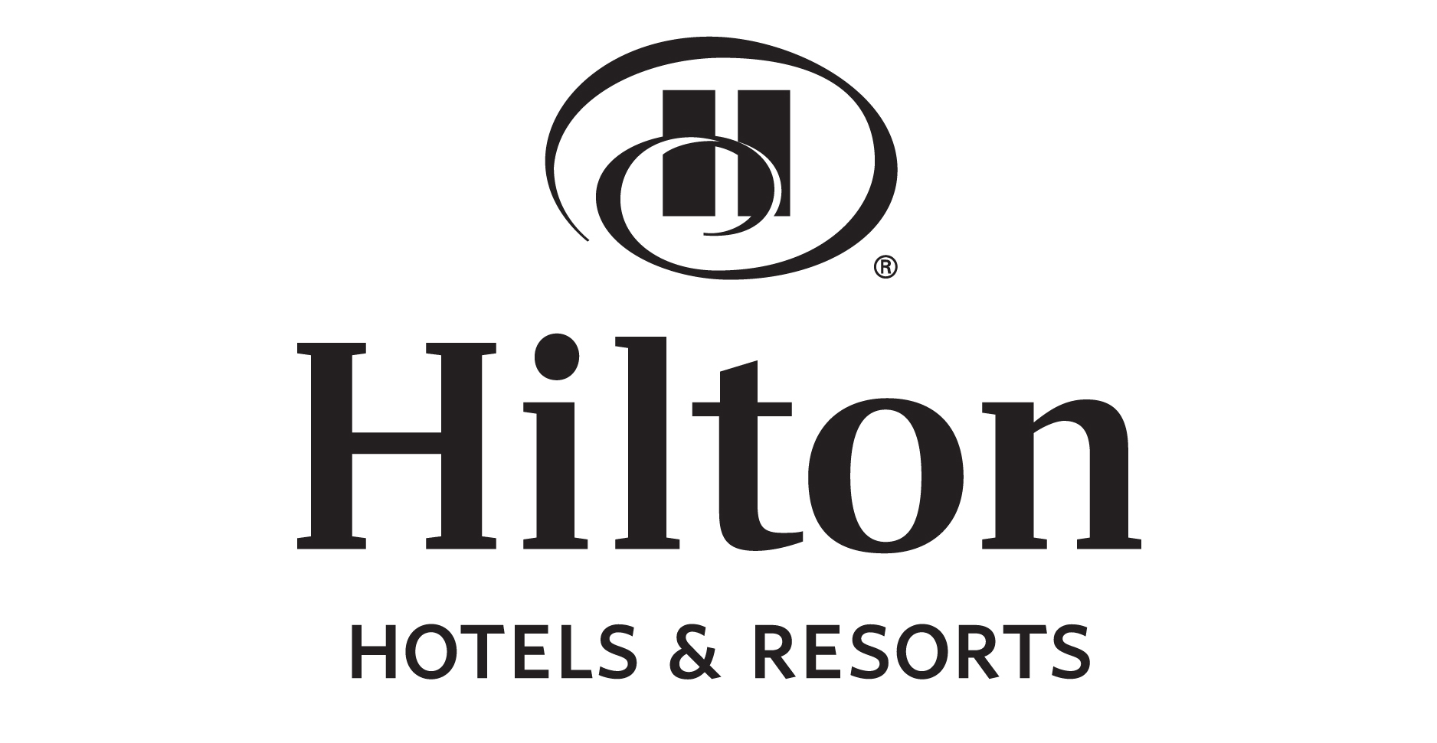
Contact: [Contact Name]  [Job Title]  [Phone Number] | FOR IMMEDIATE RELEASE

[TITLE HERE]
This should be a succinct title that entices the reader. One sentence, bolded and written in all caps.
See example on following page.

[Description Here]
One italicized sentence elaborating on the title. See example on following page.

[Opening Paragraph]
This should begin with the city, state/province, and date. See formatting example on following page. It
should contain about 3–5 lines and is considered the most important, since this catches the attention of newsreaders and journalists. Typically, questions of who, what, when, where, and why are
answered here. Keep it short and highlight what the whole release is about. See content example
on the following page.

[Additional Paragraphs]
These paragraphs go into more depth and provide additional details about the product or any events taking place. Try to include 1–2 quotes from hotel representatives.

Also, be sure to note where users can find detailed information about the product or events. Provide contact information or a website address so additional information can be found. Keep paragraphs concise and no longer than 3–5 sentences. See example on following page.

[Company Background]
This includes Hilton background. Use the supplied copy on the following page.

###
This mark lets the reader know that it is the end of the article. If more than one page is required, place the word –MORE– at the bottom of the unfinished pages.

See sample press release on following page.

Hilton Anytown, NY
555 Market Place Drive
Anytown, NY 12345
www.hiltonanytown.com

Contact: Jan Moore  Director of Human Resources  210-555-5555 | FOR IMMEDIATE RELEASE

LOCAL HOTELS COMPETE IN Housekeeping Olympics in Recognition of International Housekeeping Week.

Fun games bring out serious competition for local hotels!
Anytown, NY – July 26, 2019 – Housekeepers at area Hilton hotels are showing off their superior housekeeping skills — and having a great time in the process! During International Housekeeping Week from September 8-14, 2019, they’ll be flexing their muscles and showing off their abilities in competitions that include lightning-fast bed-making races, soap stacking contests, and more.

The games will culminate with a bed race between two local hotels. The Hilton Anytown and the Embassy Suites by Hilton Anytown will race four-wheeled beds on a three-block course through Civic Park on Oak Street on Thursday, September 12. The winner will earn the official title of “Fastest Housekeeping Team.”
“The Housekeeping Department is the backbone of any hotel,” says Roberta Jones, GM of Hilton Anytown, NY. “During this week, we really take time to recognize the tremendous contribution of our Housekeeping teams. And we do it in a way that is not only fun and exciting, but also gives them a chance to show what they can do.”
International Housekeeping Week is celebrated by over 5,000 properties throughout Hilton. “Wherever you stay during this week, take time to give a tip of the hat to your Housekeeper,” adds Ms. Jones. “This is their week to get some recognition for a job well done.”

About Hilton Hotels & Resorts: One of the most recognized names in the industry, Hilton Hotels & Resorts stands as the stylish, forward thinking global leader in hospitality. From inaugural balls and Hollywood award galas to business events and days to remember, Hilton Hotels & Resorts is where the world makes history, closes the deal, toasts special occasions and gets away from it all. The flagship brand of Hilton continues to build upon its legacy of innovation by developing products and services to meet the needs of tomorrow’s savvy global travelers while more than 144,000 Team Members shape experiences in which every Guest feels cared for, valued and respected. Today, the Hilton Hotels & Resorts portfolio includes more than 570 hotels across six continents, and the brand remains synonymous with “hotel.” Access the latest Hilton news at news.hilton.com or begin your journey at www.hilton.com.
###

