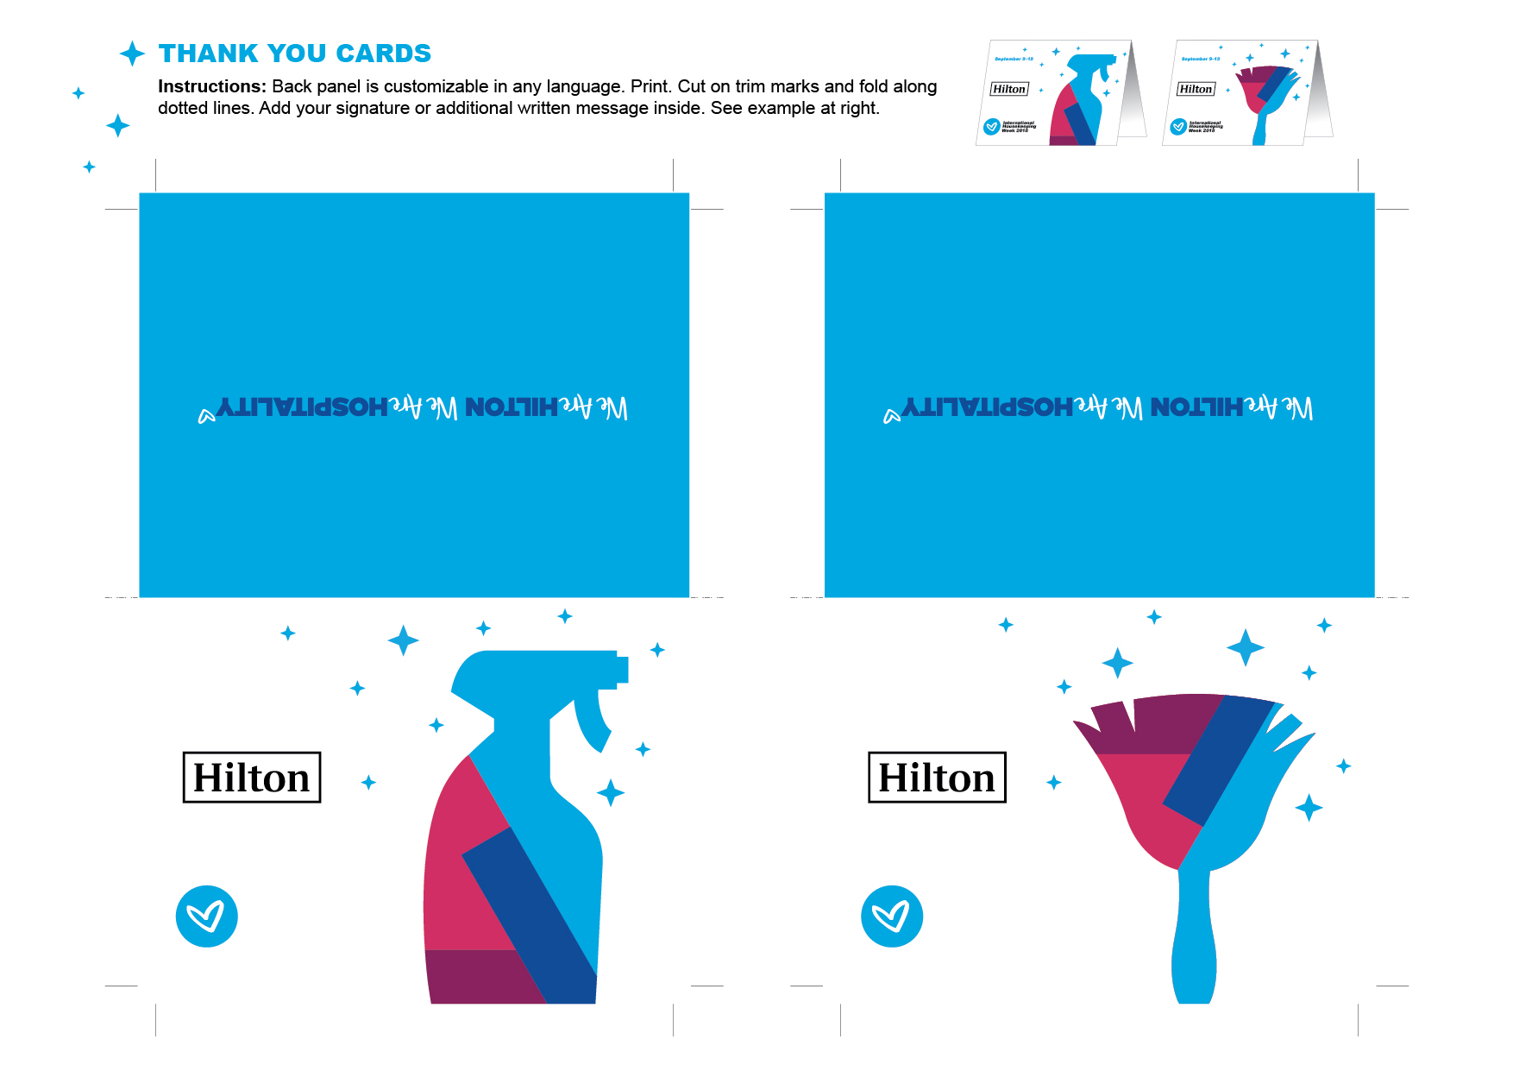

International

Housekeeping

Week 2018

International

Housekeeping

Week 2018

September 9–15

September 9–15